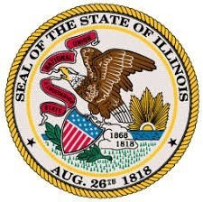

**OFFICE OF THE LIEUTENANT GOVERNOR**

Lieutenant Governor Juliana Stratton

**Rivers of Illinois Coordinating Council**

Quarterly Meeting Pursuant to 20 ILCS 4117

***Date & Time***

Wednesday, July 24, 2024

9:00 AM – 10:30 AM

***Meeting Location:***

Illinois State Office Building

555 W Monroe Street, Fourth Floor

Peoria Room

Chicago, IL 60661

Illinois State Capitol

Office of the Lieutenant Governor Stratton

401 South 2nd Street, Room 214

Springfield, IL 62706

***Agenda***

1. Call to Order and Roll Call
2. Approval of the minutes from 04/03/24. Approval of 07/24/24 agenda.
3. Chairperson’s Remarks
4. New Business
   1. Presentation by Dan Breidenstein with Living Lands and Waters

i. Followed by Q&A

* 1. Committee Updates

1. Member Updates
2. Public Comments
3. Adjournment